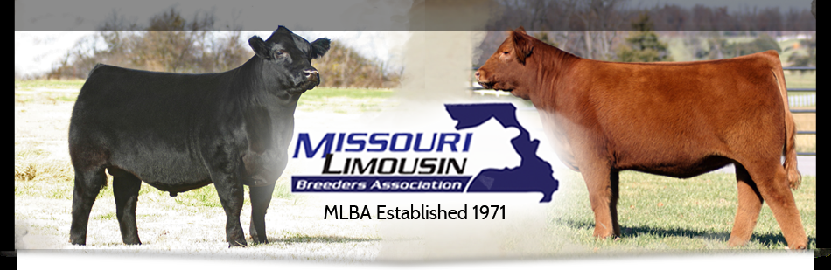

**MLBA NEWSLETTER FEBRUARY 2019**

**PRESIDENT’S COMMENTS**:  Missouri Limousin Breeders and family,

I hope this newsletter finds you all well. With spring calving season in full swing, and Missouri weather not cooperating as well as we like, I would like to remind you that the warmth of spring is coming, and greener pastures are just around the corner.

This year holds lots of opportunities within our state to showcase our breeders and what we have to offer to the rest of the cattle industry. As we move forward, I encourage each of you to either participate and/or attend some of our events happening over the next year. These events are a great opportunity to meet new breeders and to continue to build relationships with those of us who share a love for Limousin cattle.

The first event is the annual banquet and sale, April 12-13. I want to bring your attention to the new schedule of events this year outlined below. Consignment information is included and can also be found on the MLBA Facebook page and the website.

The field day show will be held at the MO State Fairgrounds, June 7-9, in conjunction with the MO Cattlemen’s All Breed Junior show. Lunch will be provided during the shows on Saturday and we invite ALL to come and enjoy food, fellowship and good cattle. The board will also conduct a meeting immediately following the open show Saturday afternoon. We encourage any of you who have any questions or suggestions for us to attend the meeting and address us. If you have anything specific you would like discussed, please let myself, or a board member know ahead of time and it will be put on the agenda.

This year Missouri has the opportunity to host the Junior National Show and All American Futurity in Springfield June 30th through July 5th. This will bring breeders from across the country to our state for an opportunity to showcase their best. As a bonus, check out an opportunity to win a FREE truck lease!

These three events all take the hard work of volunteers to make them successful. If you are interested in assisting in any way, please contact any of the board members, as it would be greatly appreciated.

Respectfully,

Shaun Edwards

**MLBA BANQUET (Friday evening 12 April)**

The MLBA 2019 Banquet will be held on Friday evening, 12 April at the Mill Center (adjacent to the cattle barn and sale arena). 6:00 pm Social Hour, 7:30 pm meal; Silent Auction, Live Auction, election of officers, Hall of Fame Inductee, Commercial Producer Award, and otherwise grand social gathering. Meal is free for all 2019 MLBA paid members and their families. 2019 MLBA membership can be purchased at the banquet.

**AMERICAN PIE SALE (Saturday 13 April @ 1:00 pm** )  
The American Pie Sale hosted by MLBA and HMLBA Boards has made a few changes for 2019. First entry deadline is February 16.  If you have not received your entry form, please contact any board member or Kiley McKinna.  The boards also decided to only allow photos of actual animals being sold in the catalog to save space and money.  However, the decision to ad reference photos will be allowed based solely on the decision of sale management. The boards of both organizations have decided to move the sale to Saturday April 13 at 1 pm. No worries about nasty weather as the new climate controlled facility— The Agriculture Legacy Building at the Laclede County Fairgrounds will be utilized for the event and will suite the needs of the sale very well.  The day of the weekend change was made to accommodate many that cannot participate in Sunday sales.  The boards agree this is a great move for our consigners and buyers.  Cattle may began arriving Friday morning and must be out of facility by Sunday at 4 pm.    Bedding will be available.  Please bring water tubs etc.  Set-up for sale will be the week just prior to sale.  All consigners are asked to stay after the sale to help in tear down and clean up. This generally does not take very long.  “Many hands make light work”!   
  
Thanks and if you have any questions please feel free to give me a call  
Jack Glendenning   
417-588-6121

**MLBA SHOWS.**

**The Heartland Regional Show** will be held 5/31-6/1 at the Westfair Fairgrounds in Council Bluffs, IA.

**The Eastern Regional Show** will be held 6/7-6/9 in Murfreesboro, TN.  The Fullblood Limousin Alliance will be holding their national show in conjunction with the Eastern Regional.

**The MLBA Field Day** will be held 6/7-6/9 at the Missouri State Fairgrounds in Sedalia, MO in conjunction with the MCA All Breeds Junior Show.  The MLBA junior show is 10 am on Saturday, 6/8 with the MLBA open show to follow at 1 pm on 6/8.  The MCA junior Limousin show will be held on Sunday 6/9 at 9 am.  MLBA Field Day entry information will be made available at the MLBA banquet in April.

**The 2019 National Junior Limousin Show & Congress** will be held 6/29-7/5 at the Ozark Empire Fairgrounds in Springfield, MO.  Please plan to attend.  If you are willing to help plan or are available to help that week, please let Ty Heavin or Shaun Edwards know.  Many hands are needed to make the week a great one for the juniors. NALJA has moved this year's NJLS&C entry deadline up to May 1.

**2019** **MLBA MEMBERSHIP.**  Our 2018 membership was eighty-two paid members. Very shortly, our treasurer, Nathan Hunt, will send out 2019 MLBA membership renewal statements to you. In addition, please inform other Limousin enthusiasts of our association’s efforts to promote Limousin cattle. Your membership name/address/contact information is included in Missouri’s page of the Heartland Limousin Association’s “Heartland Source 2018-2019” magazine. In addition, it is included on the MLBA Website referenced above. If your information is incorrect, or missing, please let MLBA Secretary Paul Junkans aware of it. [pjunkans@hotmail.com](mailto:pjunkans@hotmail.com), 573-305-0420.

**MLBA BOARD NOMINATIONS** The board is looking for nominations for board positions.  If anyone has an interest in running or knows someone who would like to please contact me at 573-301-3552 or another member of the board. Thank You

Andrew Kautsch

**2019** **COMMERCIAL PRODUCER OF THE YEAR NOMINATIONS.** If you know a commercial livestock producer in your area that uses Limousin genetics in their program and want them recognized for their efforts, please contact Mark Haden as soon as possible at 417-838-6109, [buckridgecattle@gmail.com](mailto:buckridgecattle@gmail.com) for consideration in the 2018 MLBA Commercial Producer of the Year Award to be presented at the 12 April Annual Meeting/Banquet.

**RAFFLE TICKET INFORMATION** The MLBA is hosting the 2019 National Junior Limousin Show & Congress.  In order to pay for the event, we are selling $100 raffle tickets on a one-year lease for a 2019 Chevrolet Duramax diesel truck.  Please contact Susie Heavin to purchase tickets.  Phone, or text 417.861.4580, or email at [tyandsusie@gmail.com](mailto:tyandsusie@gmail.com).  We appreciate any and all help in selling tickets.

**MLBA WEBSITE.** Be sure to visit your Missouri Limousin Breeders Association website at [www.missourilimousin.org](http://www.missourilimousin.org). A great place to view your fellow MLBA membership list, as well as upcoming events. For those of you who use Facebook, you can connect to the MLBA Facebook as well to keep abreast of happenings within our Limousin family. Mary Quigley developed and is keeping this website current.

**SPRING SALES/EVENTS**

12 Feb Heartland Limousin Association Banquet & Benefit Auction, Iowa State Fairgrounds

2 March Linhart Limousin “Business Done Right” Annual Bull Sale, Leon, IA

10 March Stockman’s Classic Bull & Female Sale, Lebanon, MO

11 March Buck Ridge Cattle Company Bred Heifer Online Sale

12 April MLBA Annual Meeting, Banquet, Lebanon, MO along with

13 April The Great American Pie Sale (joint MLBA & HMLBA), Lebanon, MO

16 March Pinegar Limousin Herdbuilder XXV, Springfield, MO

15 April Buck Ridge Cattle Company “On Target” Online Sale

23 April Linhart Limousin Divas Annual Online Fall-born Show Heifer Sale

27 April “Road to Springfield” Sale, Pinegar Limousin, Springfield, MO

7 May “Last Chance to go to the Ozarks” Online Sale, Linhart Limousin

14 May Buck Ridge Cattle Company Online Sale

Paul Junkans

MLBA Secretary

573-305-0420, [pjunkans@hotmail.com](mailto:pjunkans@hotmail.com)